Liverpool Girls’ High School
Innovation Excellence Learning

Drama ~ Stage 5 Course Outline

INTRODUCTION TO DRAMA

By participating in drama lessons, students will improve their knowledge, skills and understanding about the processes involved in making, appreciating and performing drama in a variety of styles and historical contexts.

COURSE OBJECTIVES AND OUTCOMES

1. Students will develop knowledge, understanding and skills, individually and collaboratively, through
making drama that explores a range of imagined and created situations in a collaborative drama and theatre environment

5.1.1 manipulates the elements of drama to create belief, clarity and tension in character, role, situation and action
5.1.2 contributes, selects, develops and structures ideas in improvisation and playbuilding
5.1.3 devises, interprets and enacts drama using scripted and unscripted material or text
5.1.4 explores, structures and refines ideas using dramatic forms, performance styles, dramatic techniques, theatrical conventions and technologies.

2. Students will develop knowledge, understanding and skills, individually and collaboratively, through
performing devised and scripted drama using a variety of performance techniques, dramatic forms and theatrical conventions to engage an audience

5.2.1 applies acting and performance techniques expressively and collaboratively to communicate dramatic meaning
5.2.2 selects and uses performance spaces, theatre conventions and production elements appropriate to purpose and audience
5.2.3 employs a variety of dramatic forms, performance styles, dramatic techniques, theatrical conventions and technologies to create dramatic meaning

3. Students will develop knowledge, understanding and skills, individually and collaboratively, through
appreciating the meaning and function of drama and theatre in reflecting the personal, social, cultural, aesthetic and political aspects of the human experience

5.3.1 responds to, reflects on and evaluates elements of drama, dramatic forms, performance styles, dramatic techniques and theatrical conventions
5.3.2 analyses the contemporary and historical contexts of drama
5.3.3 analyses and evaluates the contribution of individuals and groups to processes and performances in drama using relevant drama concepts and terminology

Stage 5 Drama – Year 9

By participating in Drama lessons, students will improve their knowledge, skills and understanding about the processes involved in making, appreciating and performing drama in a variety of styles and historical contexts.

WEEK 4 – TERM 4
WEEK 5 – TERM 2
Making, performing, appreciating (written reflection)

Greek Drama
5.2.1: A student applies acting and performance techniques expressively and collaboratively to communicate dramatic meaning.
5.3.2: A student analyses the contemporary and historical contexts of drama.
Mime
5.1.1: A student manipulates the elements of drama to create belief, clarity and tension in character, role, situation and action.
5. 1.4: A student explores, structures and refines ideas using dramatic forms, styles, techniques, conventions.
Improvisation / Theatre Sports
5.3.1: A student responds to, reflects on and evaluates elements of drama, dramatic forms, performance styles, dramatic techniques and theatrical conventions.
Playbuilding
5.1.2: A student contributes, selects, develops and structures ideas in improvisation and playbuilding.

Group Performance
Mime
Individual Learning
Mime

Workshop Presentation
Greek Drama

Research Task
Greek Drama

Effective Techniques in Improvisation

Theatre Sports

Making, performing, appreciating
Yearly Examination
Developing a Performance
Playbuilding
Elements of Scripted Drama
Playbuilding
FEEDBACK
Criteria based Teacher observation Self Assessment/Reflection Peer Assessment
Stage 5 Drama – Year 10

By participating in Drama lessons, students will improve their knowledge, skills and understanding about the processes involved in making, appreciating and performing drama in a variety of styles and historical contexts.

WEEK 5 – TERM 2
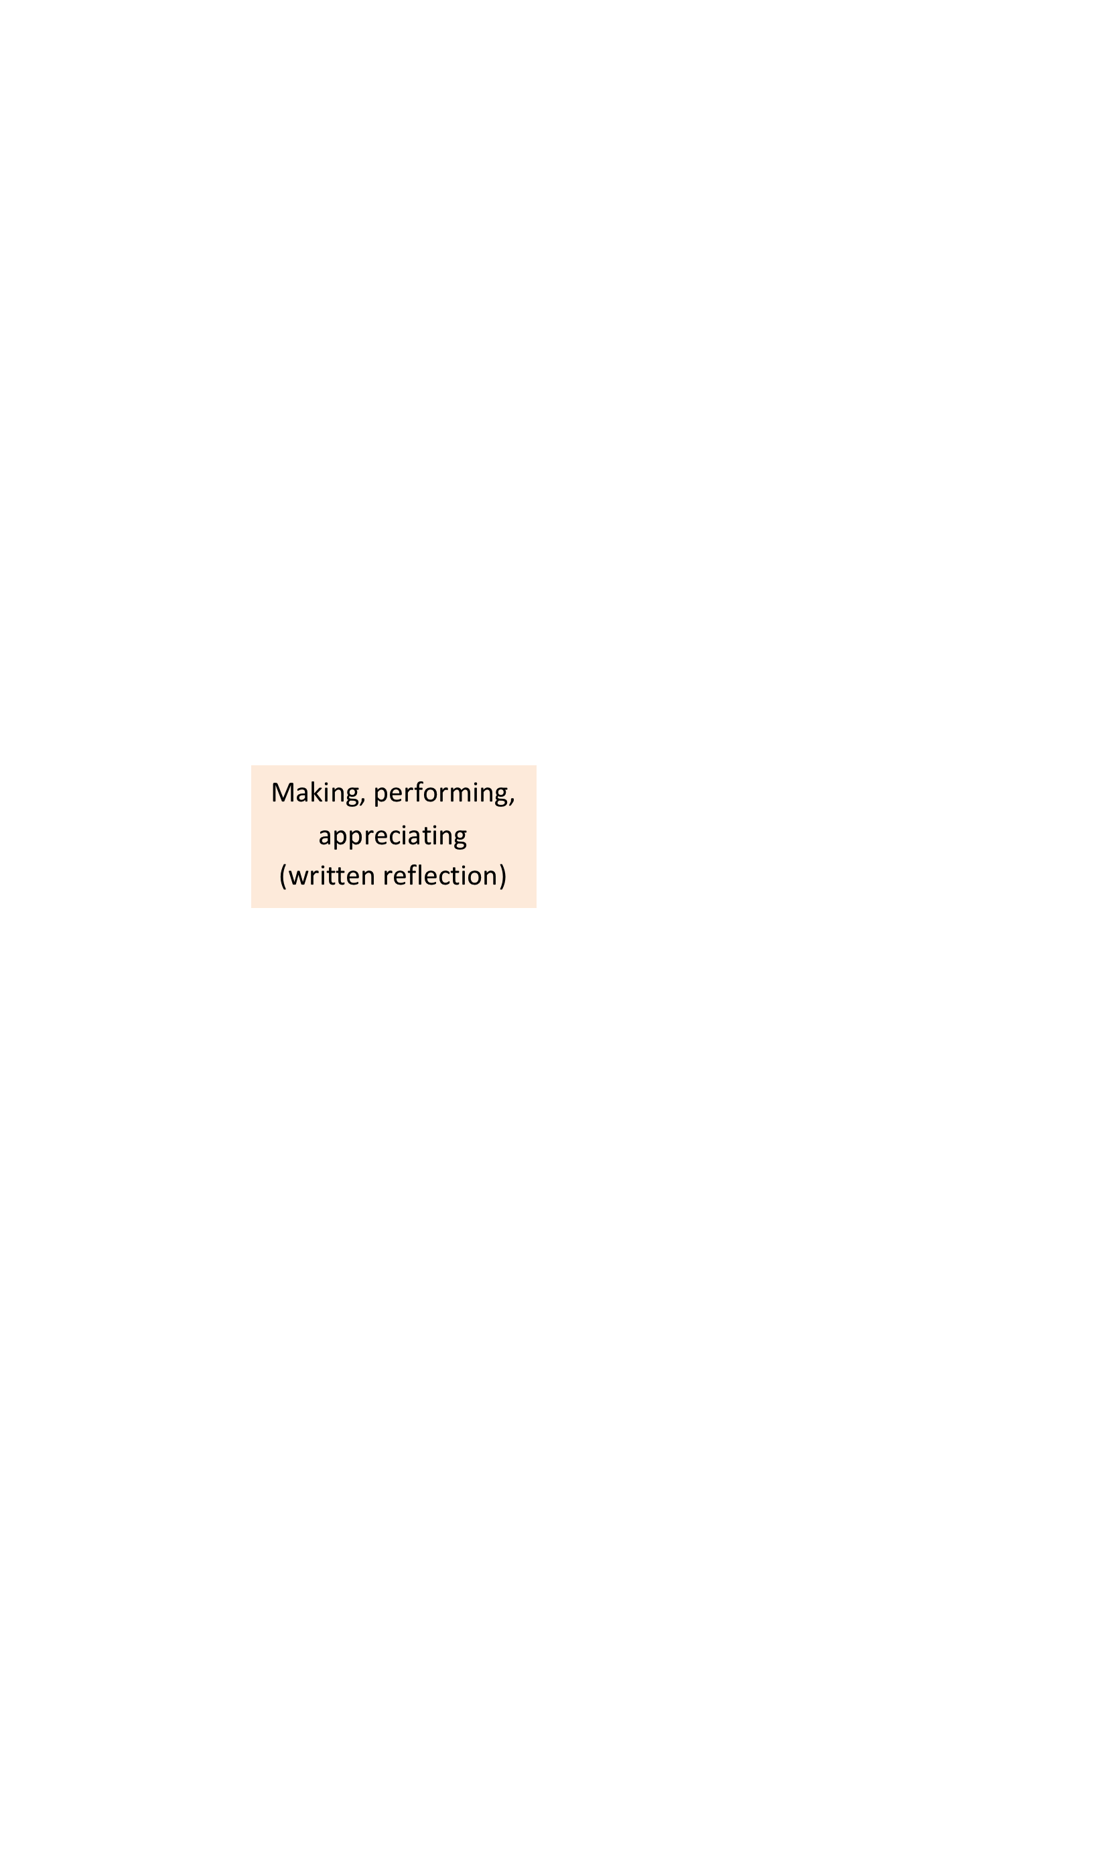

Playbuilding
5.1.2: A student contributes, selects, develops and structures ideas in improvisation and playbuilding.

Scripted Drama
5.2.2: A student selects and uses performance spaces, theatre conventions and production
elements appropriate to purpose and audience.

Commedia del’Arte
5.2.3: A student employs a variety of forms, styles,
techniques, conventions to create dramatic meaning.
5.3.2: A student analyses the contemporary and historical contexts of drama.

Monologue
5.1.3: A student devises, interprets and enacts drama using scripted and unscripted
material or text.

Group Performance
Commedia del’Arte
Research Task
Commedia del’Arte

Elements of Scripted Drama

Scripted Drama in Performance

Developing a Performance
Playbuilding

Creating a Character
Monologue
Individual Performance
Monologue

WEEK 4 – TERM 2
Making, performing, appreciating
Yearly Examination
Making, performing, appreciating (written reflection)
FEEDBACK
Criteria based Teacher observation Self Assessment/Reflection Peer Assessment

Drama ~ Performance Descriptor

Areas for Assessment
Making
Performing
Appreciating

Grade A

A student at this grade typically:
- communicates a sophisticated understanding of the elements of drama in the integrated practices of making, performing and appreciating drama within playbuilding and other dramatic contexts.
- perceptively develops and refines their work, individually and collaboratively, using a range of dramatic forms, structures, devices, acting and performance techniques to create dynamic and engaging works with an intended meaning for an audience.
- demonstrates excellence in improvisation, playbuilding, the enactment and interpretation of scripts, texts and other dramatic forms and performance styles.
- selects and manipulates performance spaces, technologies and elements of production to communicate different dramatic intentions.
- researches and critically assesses the contemporary and historical contexts of drama.
- evaluates the contribution of groups and individuals, using appropriate drama terminology.
- analyses and synthesises drama with a sophisticated awareness of the unique relationship between performer and audience.

Grade B

A student at this grade typically:
- demonstrates a thorough understanding of the elements of drama in the integrated practices of making, performing and appreciating drama within playbuilding and other dramatic contexts.
- capably develops their work, individually and collaboratively, using dramatic forms, structures, devices, acting and performance techniques to create effective and engaging works with an intended meaning for an audience.
- competently improvises, playbuilds, enacts and interprets scripts, texts and other dramatic forms and performance styles.
- confidently uses performance spaces, technologies and elements of production to communicate dramatic intentions.
- researches and analyses the contemporary and historical contexts of drama.
- assesses the contributions of groups and individuals using appropriate drama terminology.
- analyses drama with an awareness of the relationship between performer and audience.

Grade C

A student at this grade typically:
- demonstrates a sound understanding of the elements of drama through the practices of making, performing and appreciating drama within the context of playbuilding and other dramatic contexts.
- develops their work, individually and collaboratively, using dramatic forms, structures, devices, acting and performance techniques to create engaging works with an intended meaning for an audience.
- improvises, playbuilds, and enacts scripts, texts and other dramatic forms and performance styles.
- uses performance spaces, technologies and elements of production to communicate a dramatic intention.
- researches and describes the contemporary and historical contexts of drama.
- describes the contribution of groups and individuals using drama terminology.
- describes the relationship between performer and audience.

Grade D

A student at this grade typically:
- demonstrates a basic understanding of the elements of drama through the practices of making, performing and appreciating drama within the context of playbuilding and some other dramatic contexts.
- develops their work using basic dramatic forms and performance techniques to create drama for an audience.
- demonstrates limited skills in improvisation, playbuilding and other dramatic forms.
- uses aspects of performance spaces, technologies and elements of production.
- conducts basic research and describes some contexts of drama.
- recognises the contribution of groups and individuals, using limited drama terminology.
- recognises the relationship between performer and audience.

Grade E

A student at this grade typically:
- participates, with teacher support, in the practices of making, performing and appreciating drama.
- has an elementary understanding of some elements of drama and performance skills required to create drama for an audience.
- demonstrates very limited skills in improvisation, playbuilding and other dramatic forms.
- uses some aspects of performance spaces and elements of production.
- with guidance, conducts basic research.
- recognises the contribution of some groups and individuals.
- recognises aspects of the relationship between performer and audience.

