Liverpool Girls’ High School
Innovation Excellence Learning

Geography ~ Stage 5 Course Outline

INTRODUCTION TO GEOGRAPHY

Stage 5 Geography incorporates learning related to Australian geography and the interaction of human and physical geography in a local context.

The study of geography develops a wide range of skills such as gathering, organising, evaluating and communicating geographical information from a variety of primary and secondary sources, including fieldwork. It provides for students to use a wide variety of geographical tools including information and communication technologies (ICT).

COURSE OBJECTIVES AND OUTCOMES

Students will develop skills in acquiring, processing and communicating geographical information;

4.1 identifies and gathers geographical information;
4.2 organises and interprets geographical information;
4.3 uses a range of written, oral and graphic forms to communicate geographical information.

Students will develop skills in choosing and applying appropriate geographical tools;

4.4 uses a range of geographical tools.

Students will develop knowledge and understanding about the characteristics and spatial distribution of environments;

4.5 demonstrates a sense of place about global environments.

Students will develop knowledge and understanding about how people and communities modify, and are affected by, the environment;

4.6 describes the geographical processes that form and transform environments;
4.7 identifies and discusses geographical issues from a range of perspectives.

Students will develop knowledge and understanding about how physical, social, cultural, economic and political factors shape communities, including the global community;

4.8 describes the interrelationships between people and environments;
4.9 describes differences in life opportunities throughout the world.

Students will develop knowledge and understanding about civics for informed and active citizenship;

4.10 explains how geographical knowledge, understanding and skills combine with knowledge of civics to contribute to informed citizenship.

Stage 5 Geography – Year 9
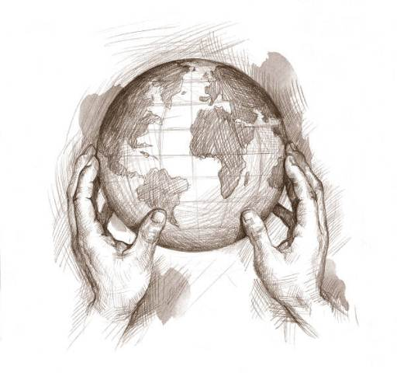
Year 9
BACK
FEED
Self assessment, Peer assessment, Teacher observation and Criteria based
Evidence of Learning- formal assessment and informal assessment (Bookwork, class discussions and skills)
Stage 5 Geography – Year 10
FEED
Self assessment, Peer assessment, Teacher observation and Criteria based
Evidence of Learning- formal assessment and informal assessment (Bookwork, class discussions and skills)
Year 10

Geography ~ Performance Descriptors

Areas for Assessment
Communication
Geographical tools and skills
Geographical knowledge

Grade A

A student at this grade typically:
- displays sophisticated skills to select, gather and organise complex geographical information and uses an extensive range of written, oral and graphic forms to communicate it effectively.
- exhibits extensive skills to select and proficiently apply geographical tools appropriate to the spatial and ecological dimensions of Australia.
- demonstrates an extensive sense of place of Australian environments and an extensive understanding of the geographical processes that form and transform them.
- explains and analyses different perspectives of geographical issues at a range of scales.
- demonstrates extensive knowledge and understanding of Australian environments and communities, the interactions of people with the environment and the factors that shape communities.
- displays extensive knowledge of civics and analyses links between civics and informed and active citizenship in relation to geographical issues at a range of scales.

Grade B

A student at this grade typically:
- displays high level skills to select, gather, organise and communicate complex geographical information in a broad range of written, oral and graphic forms.
- exhibits high level skills to select and apply geographical tools appropriate to the spatial and ecological dimensions of Australia.
- demonstrates a thorough sense of place of Australian environments and a thorough understanding of the geographical processes that form and transform them.
- explains different perspectives of geographical issues at a range of scales.
- demonstrates thorough knowledge and understanding of Australian environments and communities, the interactions of people with the environment and the factors that shape communities.
- displays thorough knowledge of civics and explains links between civics and informed and active citizenship in relation to geographical issues.

Grade C

A student at this grade typically:
- displays sound skills to select, gather, organise and communicate geographical information using a range of written, oral and graphic forms.
- exhibits sound skills to select and apply geographical tools appropriate to the spatial and ecological dimensions of Australia.
- demonstrates a sound sense of place of Australian environments and adequate understanding of the geographical processes that form and transform them.
- describes different perspectives of geographical issues.
- demonstrates sound knowledge and understanding of Australian environments and communities, the interactions of people with the environment and the factors that shape communities.
- displays broad knowledge of civics and describes links between civics and informed and active citizenship.

Grade D

A student at this grade typically:
- displays basic skills to select, gather, organise and communicate geographical information using a range of written, oral and graphic forms.
- exhibits some skills to select and apply geographical tools appropriate to a range of spatial and ecological dimensions of Australia.
- demonstrates a basic sense of place of Australian environments and some understanding of the geographical processes that form and transform them.
- outlines different perspectives of Australian geographical issues.
- demonstrates basic knowledge and understanding of Australian environments and communities, a range of interactions of people with the environment and a range of factors that shape communities.
- displays some knowledge of civics and identifies links between civics and citizenship.

Grade E

A student at this grade typically:
- displays very limited skills to select, gather, organise and communicate geographical information using a limited range of written, oral and graphic forms.
- exhibits very limited skills to select and apply geographical tools to some spatial and ecological dimensions of Australia.
- demonstrates some sense of place of Australian environments and identifies some geographical processes that form and transform them.
- recognises some different perspectives of geographical issues.
- demonstrates elementary knowledge and understanding of Australian environments and communities, some interactions of people with the environment and some factors that shape communities.
- identifies some aspects of civics and recognises some links between civics and citizenship.

