Liverpool Girls’ High School
Innovation Excellence Learning

History Elective ~Stage 5 Course Outlines

INTRODUCTION TO HISTORY ELECTIVE

COURSE OBJECTIVES AND OUTCOMES

Students develop a knowledge and understanding of history and historical inquiry
E5.1 applies an understanding of history, heritage, archaeology and the methods of historical inquiry
E5.2 examines the ways in which historical meanings can be constructed through a range of media

Students develop a knowledge and understanding of past societies and historical periods
E5.3 sequences major historical events or heritage features, to show an understanding of continuity, change and causation
E5.4 explains the importance of key features of past societies or periods, including groups and personalities
E5.5 evaluates the contribution of cultural groups, sites and/or family to our shared heritage

Students develop skills to undertake the processes of historical inquiry
E5.6 identifies, comprehends and evaluates the usefulness of historical sources in an historical inquiry process
E5.7 explains different contexts, perspectives and interpretations about the past
E5.8 selects and analyses a range of historical sources to locate information relevant to an historical inquiry

Students develop skills to communicate their understanding of history
E5.9 applies a range of relevant historical terms and concepts when communicating an understanding of the past
E5.10 selects and uses appropriate oral, written, visual and digital forms to communicate effectively about the past for different audiences

Stage 5 Elective History – Year 9

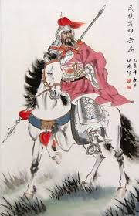 Year Nine Elective History 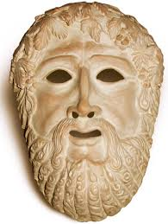

The aim of this course is to introduce students to aspects of world history, including the contribution of past societies to our understanding of the present. Students will develop historical skills and understanding through individual and group historical research investigations.

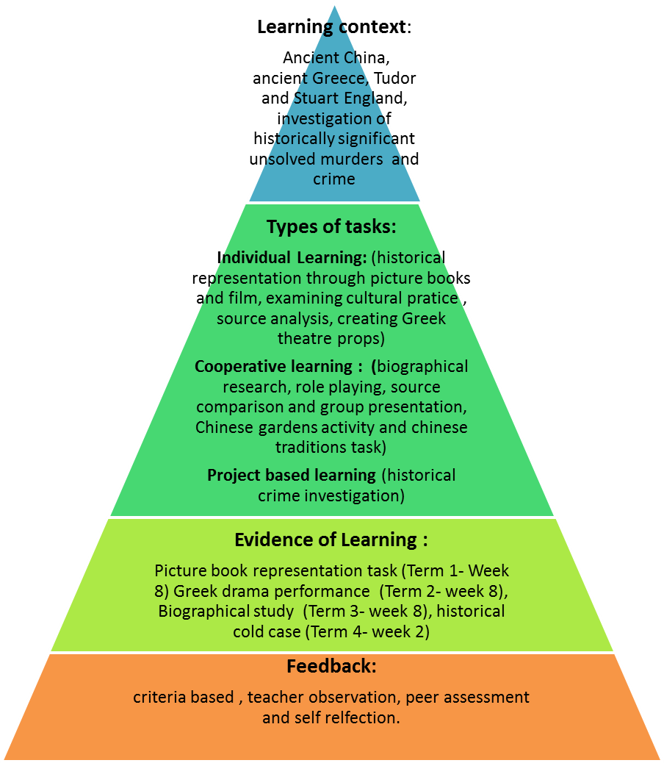

Stage 5 Elective History (Big History) – Year 9

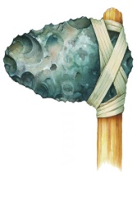 Year Nine Big History

By participating in the global big history project, students will improve their cross curricular knowledge, skills and cosmological understanding about the universe via textual, visual and multimedia and transmedia form. They will develop their logic, evidence gather, critical thinking, creativity, research skills and applied intuition in discovering aspects of the formation of the universe to modern times.

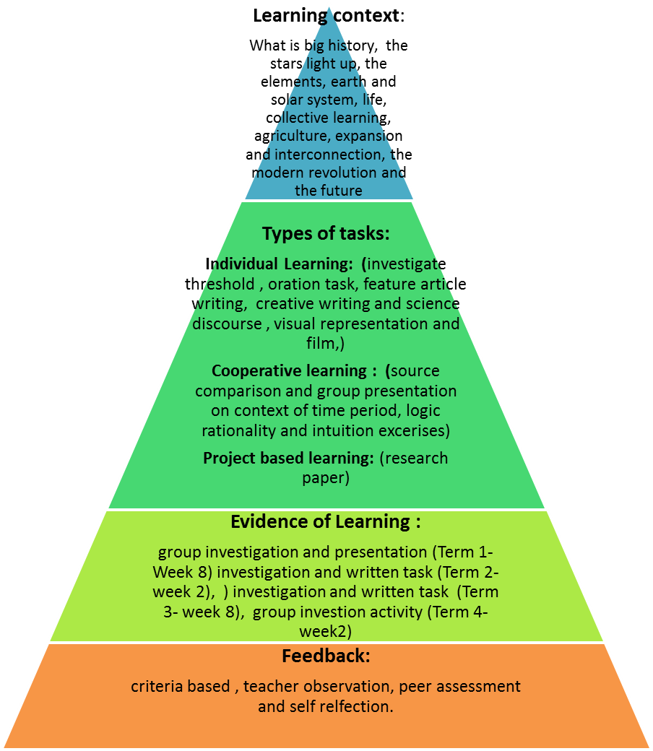

Stage 5 Elective History – Year 10

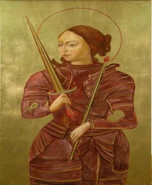Year Ten Elective History

By participating in history lessons, students will improve their knowledge, skills and understanding of civil rights through specific case studies and a biographical study of important and iconic women. During this year students will also study the phenomena of genocide in a range of historical contexts and the development of the United Nations.

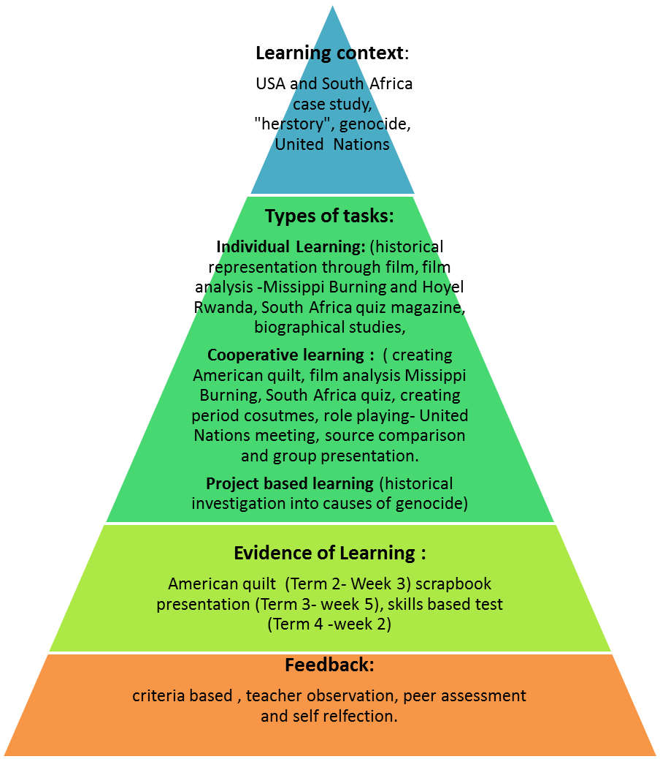

History Elective ~ Performance Descriptor

Areas for Assessment
Historical understanding
Historical knowledge
Research and historical inquiry skills
Communication

Grade A

A student at this grade typically:
- demonstrates and applies a detailed and extensive knowledge and understanding of the nature of history, heritage and archaeology, and the methods of historical inquiry.
- assesses the importance of key features, personalities and groups in past societies, and accurately sequences major historical events to explain causation, continuity and change.
- independently evaluates the contribution of a wide range of cultural groups, sites and/or families to our shared heritage.
- assesses different perspectives, interpretations and constructions of the past.
- evaluates a range of sources and synthesises information from them to undertake historical inquiry.
- communicates an extensive understanding of history by constructing sustained and coherent explanations and arguments for different audiences, using a variety of oral, written and other forms.
- displays a sophisticated use of historical terms and concepts.

Grade B

A student at this grade typically:
- demonstrates and applies a detailed knowledge and understanding of the nature of history, heritage and archaeology, and the methods of historical inquiry.
- explains the importance of key features, personalities and groups in past societies, and accurately sequences major historical events to explain causation, continuity and change.
- analyses the contribution of cultural groups, sites and/or families to our shared heritage.
- explains different perspectives, interpretations and constructions of the past.
- selects and interprets a range of sources and draws conclusions about their usefulness in a historical inquiry.
- communicates a thorough understanding of history by constructing coherent explanations and arguments for different audiences, using a variety of oral, written and other forms.
- appropriately uses a wide range of historical terms and concepts.

Grade C

A student at this grade typically:
- demonstrates sound knowledge and understanding of the nature of history, heritage and archaeology, and the methods of historical inquiry.
- describes key features, personalities and groups in past societies, and sequences major historical events to explain causation, continuity and change.
- describes the contribution of cultural groups, sites and/or families to our shared heritage.
- describes different perspectives, interpretations and constructions of the past.
- locates, selects and organises relevant information from a number of sources to undertake historical inquiry.
- communicates a sound understanding of history by creating explanations and arguments, using a range of oral, written and other forms.
- uses a range of historical terms and concepts.

Grade D

A student at this grade typically:
- demonstrates basic knowledge and understanding of the nature of history, heritage and archaeology, and the methods of historical inquiry.
- identifies some key features, personalities or groups in past societies, sequences events and identifies factors contributing to continuity and change.
- identifies some contributions of cultural groups, sites and/or families to our shared heritage.
- identifies different perspectives, interpretations and constructions of the past.
- locates and selects relevant information from sources, and summarises the main ideas to engage in basic, structured research tasks.
- communicates a basic understanding of history by creating descriptions and simple explanations, in a range of oral, written and other forms.
- uses some appropriate historical terms and concepts.

Grade E

A student at this grade typically:
- demonstrates elementary knowledge and understanding of some aspects of the nature of history, heritage and archaeology, and the methods of historical inquiry.
- recognises some key features, personalities or groups in past societies, and recounts simply some historical events in chronological order.
- recognises some contributions of cultural groups, sites and/or families to our shared heritage.
- recognises some different perspectives within historical accounts, with guidance.
- locates basic information from sources to construct simple historical recounts.
- communicates an elementary understanding of history by creating basic historical recounts in a limited range of forms.
- uses simple historical terms and concepts.

