Liverpool Girls’ High School
Innovation Excellence Learning

History ~ Stage 5 Course Outline

INTRODUCTION TO HISTORY

COURSE OBJECTIVES AND OUTCOMES

- develop knowledge and understanding of the nature of history and significant changes and developments from the past, the modern world and Australia
- develop knowledge and understanding of ideas, movements, people and events that shaped past civilisations, the modern world and Australia
A student …
HT5-1 explains and assesses the historical forces and factors that shaped the modern world and Australia;
HT5-2 sequences and explains the significant patterns of continuity and change in the development of the modern world and Australia;
HT5-3 explains and analyses the motives and actions of past individuals and groups in the historical contexts that shaped the modern world and Australia;
HT5-4 explains and analyses the causes and effects of events and developments in the modern world and Australia;
HT5-5 identifies and evaluates the usefulness of sources in the historical inquiry process;
HT5-6 uses relevant evidence from sources to support historical narratives, explanations and analyses of the modern world and Australia;
HT5-7 explains different contexts, perspectives and interpretations of the modern world and Australia;
HT5-8 selects and analyses a range of historical sources to locate information relevant to an historical inquiry;
HT5-9 applies a range of relevant historical terms and concepts when communicating an understanding of the past;
HT5-10 selects and uses appropriate oral, written, visual and digital forms to communicate effectively about the past for different audiences.

Stage 5 History – Year 9

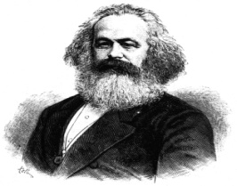 Year Nine History

By participating in history lessons, students will improve their knowledge, skills and understanding of the historical development of ideas and national building. During this year students will investigate the foundations of the modern world, studying key events and ideas. They will also develop an understanding of Australia's place as an emerging nation and role in the world wars.

Stage 5 History – Year 10

Year Ten History 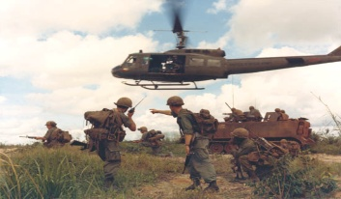

By participating in history lessons, students will improve their knowledge, skills and understanding of civil rights , the impact of the feminist movement and the migrant experience. During this year students will study Australia's place in late twentieth century geopolitics and the development of popular culture as an expression of historical context.

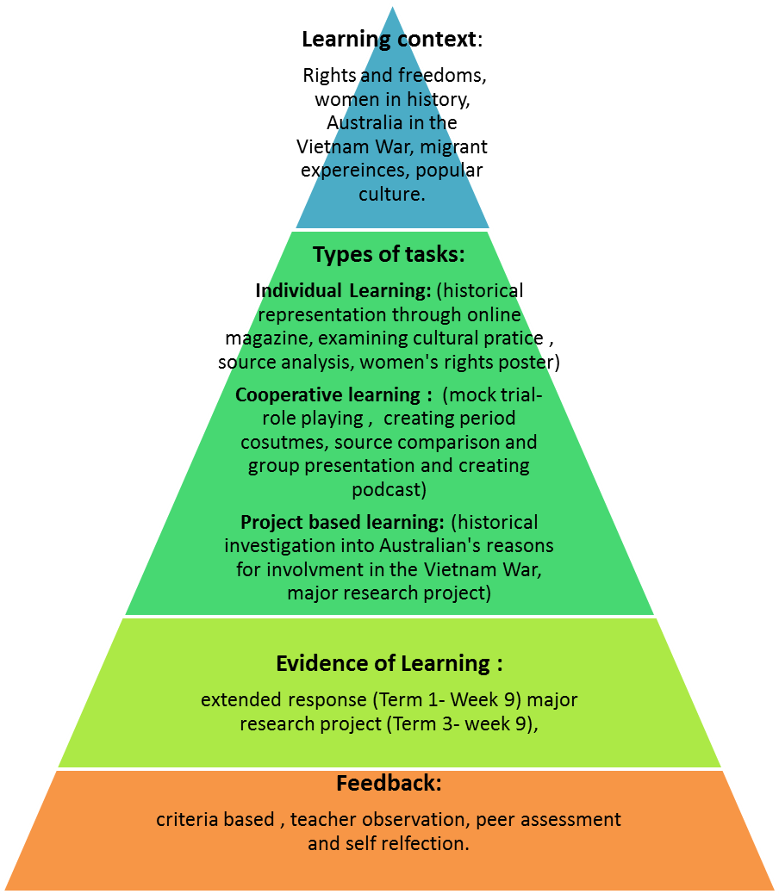

History ~ Performance Descriptor

Areas for Assessment
Historical knowledge
Research and historical inquiry skills
Communication

Grade A

A student at this grade typically:
- demonstrates extensive knowledge and understanding of significant historical forces and factors that shaped the modern world and Australia
- demonstrates extensive knowledge and understanding of the motives and actions of past individuals and groups in the historical contexts that shaped the modern world and Australia
- draws historical conclusions based on an understanding of chronology, continuity and change
- evaluates a range of sources for their usefulness and synthesises evidence from them to support an historical inquiry
- analyses and assesses the importance of the causes and effects of historical events and developments
- analyses and accounts for different perspectives and interpretations of the past
- communicates an understanding of the past by constructing sustained explanations and arguments for different audiences, in appropriate oral, written, visual and digital forms, with a sophisticated use of relevant historical terms and concepts.

Grade B

A student at this grade typically:
- demonstrates thorough knowledge and understanding of significant historical forces and factors that shaped the modern world and Australia
- demonstrates thorough knowledge and understanding of the motives and actions of past individuals and groups in the historical contexts that shaped the modern world and Australia
- explains historical events based on an understanding of chronology, continuity and change
- selects and analyses a range of sources and draws conclusions about their usefulness for an historical inquiry
- explains and analyses causes and effects of historical events and developments
- explains and compares different perspectives and interpretations of the past
- communicates an understanding of the past by constructing explanations and arguments for different audiences, in appropriate oral, written, visual and digital forms, using a range of relevant historical terms and concepts.

Grade C

A student at this grade typically:
- demonstrates sound knowledge and understanding of significant historical forces and factors that shaped the modern world and Australia
- demonstrates sound knowledge and understanding of the motives and actions of past individuals and groups in the historical contexts that shaped the modern world and Australia
- sequences historical events and describes significant patterns of continuity and change
- selects and organise sources to locate relevant information to support an historical inquiry
- explains causes and effects of historical events and developments
- explains different perspectives and interpretations of the past
- communicates an understanding of the past through explanations and arguments in appropriate oral, written, visual and digital forms, using relevant historical terms and concepts.

Grade D

A student at this grade typically:
- demonstrates basic knowledge and understanding of significant historical forces and factors that shaped the modern world and Australia
- demonstrates basic knowledge and understanding of the motives and actions of past individuals and groups in the historical contexts that shaped the modern world and Australia
- sequences some historical events and identifies factors contributing to continuity and change
- selects and organises relevant information from sources and summarises the main ideas to answer historical questions
- describes some causes and effects of historical events and developments
- identifies different perspectives and interpretations of the past
- communicates an understanding of the past by describing historical events and issues in appropriate oral, written, visual and digital forms, using some historical terms and concepts.

Grade E

A student at this grade typically:
- demonstrates elementary knowledge and understanding of significant historical forces and factors that shaped the modern world and Australia
- demonstrates elementary knowledge and understanding of the motives and actions of past individuals and groups in the historical contexts that shaped the modern world and Australia
- recounts some historical events in chronological order and identifies significant changes
- with guidance, locates information from sources to answer historical questions
- identifies some causes and effects of historical events
- recognises different perspectives within historical accounts
- communicates an understanding of the past through basic accounts of events and issues in oral, written, visual or digital forms, using simple historical terms and concepts

