Liverpool Girls’ High School
Innovation Excellence Learning

Photographic and digital media
Stage 5 Course Outline

INTRODUCTION TO PHOTOGRAPHIC AND DIGITAL MEDIA

COURSE OBJECTIVES AND OUTCOMES

Making

Students will develop knowledge, understanding and skills to make photographic and digital works informed by their understanding of practice, the conceptual
framework and the frames

Practice | 5.1 | develops range and autonomy in selecting and applying photographic and digital conventions and procedures to make photographic and digital works
Conceptual framework | 5.2 | makes photographic and digital works informed by their understanding of the function of and relationships between artist–artwork–world–audience
Frames | 5.3 | makes photographic and digital works informed by an understanding of how the frames affect meaning
Representation | 5.4 | investigates the world as a source of ideas, concepts and subject matter for photographic and digital works
Conceptual strength and meaning | 5.5 | makes informed choices to develop and extend concepts and different meanings in their photographic and digital works
Resolution | 5.6 | selects appropriate procedures and techniques to make and refine photographic and digital works

Critical and historical interpretations

Students will develop knowledge, understanding and skills to critically and historically interpret photographic and digital works informed by their understanding of practice,
the conceptual framework and the frames

Practice | 5.7 | applies their understanding of aspects of practice to critically and historically interpret photographic and digital works
Conceptual framework | 5.8 | uses their understanding of the function of and relationships between the artist–artwork–world–audience in critical and historical interpretations of photographic and digital works
Frames | 5.9 | uses the frames to make different interpretations of photographic and digital works
Representation | 5.10 | constructs different critical and historical accounts of photographic and digital works

Stage 5 Photographic and Digital Media – Year 9

Learning Context/ Units of Work:

“The Photogram”, “Snap! Pop! The Pinhole Camera”, “Abandoned Spaces”, “Make My World Surreal”

Types of Tasks:

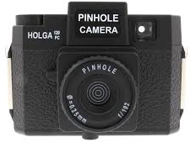
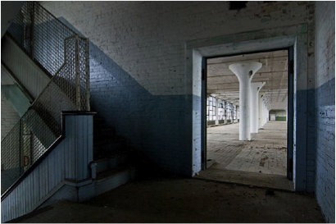
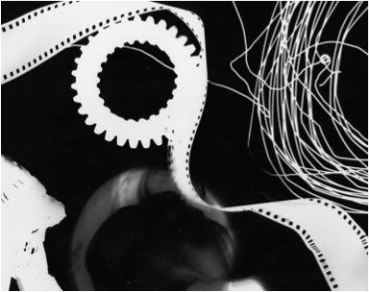

Formal Tasks for Evidence of Learning: Ongoing throughout the term…

Photographic and Digital Media ~ Performance Descriptor

Areas for Assessment
Making
Critical and historical interpretations

Grade A

A student at this grade typically:
- makes sophisticated photographic and digital works with a perceptive understanding of how the four frames and conceptual framework can be used to develop meaning and represent ideas and interests in the world.
- demonstrates highly developed technical accomplishment and refinement in making and resolving sophisticated photographic and digital works in still, interactive and/or moving forms. They experiment, work with autonomy, and reflect on their actions, judgements and artistic intentions to make informed choices about their photographic and digital works.
- synthesises their understanding of practice, the conceptual framework and the frames to confidently interpret, explain and make judgements about photographic and digital media.
- demonstrates a perceptive understanding of the function of, and relationships between, the agencies of the conceptual framework, and how the frames can be used to represent a point of view.

Grade B

A student at this grade typically:
- makes accomplished photographic and digital works with a clear understanding of how the four frames and agencies of the conceptual framework can be used to develop meaning and represent ideas and interests in the world.
- demonstrates well-developed technical accomplishment and refinement to make photographic and digital works in still, interactive and/or moving forms. They experiment and reflect on their actions, judgements and artistic intentions to make photographic and digital works.
- interprets, explains and makes judgements about photographic and digital media, applying an understanding of practice, the conceptual framework and the frames.
- demonstrates a clear understanding of the function of, and relationships between, the agencies of the conceptual framework, and how the frames can be used to represent a point of view.

Grade C

A student at this grade typically:
- makes a variety of photographic and digital works with an understanding of how the frames and agencies of the conceptual framework can be used to develop meaning and represent ideas and interests in the world.
- demonstrates sound technical accomplishment in making photographic and digital works in still, interactive and/or moving forms that represent their actions, judgements and artistic intentions.
- interprets, explains and makes judgements about photographic and digital media, by engaging with aspects of practice, the conceptual framework and some of the frames.
- demonstrates understanding of the function of, and relationships between, some agencies of the conceptual framework, and how some of the frames can be used to represent a point of view.

Grade D

A student at this grade typically:
- makes photographic and digital works, and identifies how some of the frames and agencies of the conceptual framework can be used to explore ideas and interests in the world.
- represents their artistic intentions in photographic and digital works in still, interactive and/or moving forms, demonstrating some technical accomplishment.
- makes limited interpretations and judgements about photographic and digital media, involving a foundational understanding of practice and the conceptual framework, and some of the frames.
- recognises the function of, and relationships between, some agencies of the conceptual framework, and how some of the frames can be used to represent a point of view.

Grade E

A student at this grade typically:
- makes simple photographic and digital works with an elementary understanding of the frames and the conceptual framework.
- recognises that ideas, interests in the world and artistic intentions can be represented in still, interactive and/or moving forms, and demonstrates limited technical accomplishment.
- makes simple interpretations about photographic and digital media, with some reference to practice, the frames and conceptual framework.
- with teacher support, recognises some function of, and relationships between, some agencies of the conceptual framework, and that the frames can be used to represent a point of view.

