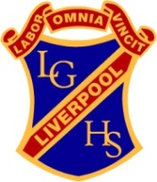
Liverpool Girls’ High School
Innovation Excellence Learning

Visual Arts ~ Stage 4 Course Outline

INTRODUCTION TO THE STAGE 4 VISUAL ARTS COURSE

By participating in visual arts lessons, students will foster interest and enjoyment in the making and studying of art. Students will critically and historically interpret art by exploring meanings and values in artworks and create their own works by exploring a variety of skills and techniques.

COURSE OBJECTIVES AND OUTCOMES

Artmaking

Students will develop knowledge, understanding and skills to make artworks informed by their understanding of practice, the conceptual framework and the frames
Practice | 4.1 uses a range of strategies to explore different artmaking conventions and procedures to make artworks
Conceptual framework | 4.2 explores the function of and relationships between artist – artwork – world – audience
Frames | 4.3 makes artworks that involve some understanding of the frames
Representation | 4.4 recognises and uses aspects of the world as a source of ideas, concepts and subject matter in the visual arts
Conceptual strength and meaning | 4.5 investigates ways to develop meaning in their artworks
Resolution | 4.6 selects different materials and techniques to make artworks

Critical and historical studies

Students will develop knowledge, understanding and skills to critically and historically interpret art informed by their understanding of practice, the conceptual framework and the frames
Practice | 4.7 explores aspects of practice in critical and historical interpretations of art
Conceptual framework | 4.8 explores the function of and relationships between the artist – artwork – world – audience
Frames | 4.9 begins to acknowledge that art can be interpreted from different points of view
Representation | 4.10 recognises that art criticism and art history construct meanings

Stage 4 Visual Arts - YEAR 7
Learning Contexts / Units of Work

“The Elements of Design”, “Mapping”, “Cubist Portraits”, “Appropriated Collage”

Types of Tasks:

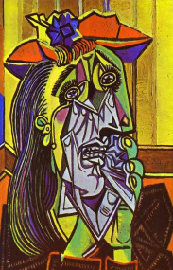
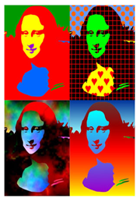
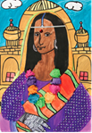

Formal Tasks for Evidence of Learning: Ongoing throughout the term…

Stage 4 - Visual Arts - YEAR 8
Learning Contexts / Units of Work:

“The Built Environment”, “Pop Art”

Types of Tasks:
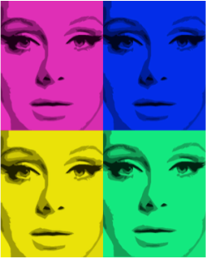
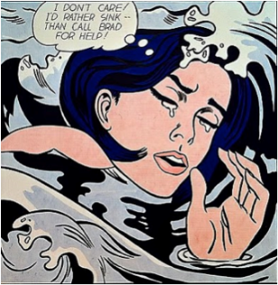
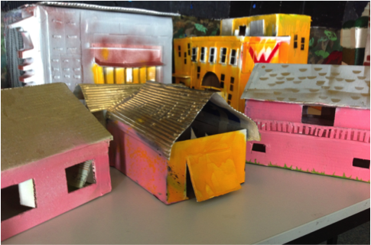
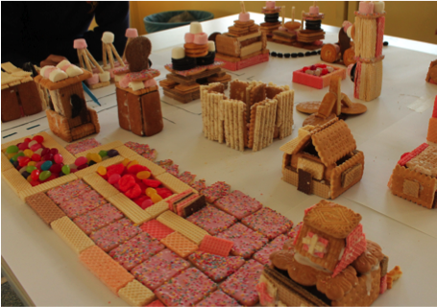

Formal Tasks for Evidence of Learning: Ongoing throughout the term…

