Liverpool Girls’ High School
Innovation Excellence Learning

Visual Design ~ Stage 5 Course Outline

INTRODUCTION TO VISUAL DESIGN

COURSE OBJECTIVES AND OUTCOMES

Making
Students will develop knowledge, understanding and skills to make visual design artworks informed by their understanding of practice, the conceptual framework and the frames.
Practice | 5.1 | develops autonomy in selecting and applying visual design conventions and procedures to make visual design artworks
Conceptual framework | 5.2 | makes visual design artworks informed by their understanding of the function of and relationships between artist – artwork – world – audience
Frames | 5.3 | makes visual design artworks informed by an understanding of how the frames affect meaning
Representation | 5.4 | investigates and responds to the world as a source of ideas, concepts and subject matter for visual design artworks
Conceptual strength and meaning | 5.5 | makes informed choices to develop and extend concepts and different meanings in their visual design artworks
Resolution | 5.6 | selects appropriate procedures and techniques to make and refine visual design artworks

Critical and historical interpretations
Students will develop knowledge, understanding and skills to critically and historically interpret visual design artworks informed by their understanding of practice, the conceptual framework and the frames
Practice | 5.7 | applies their understanding of aspects of practice to critically and historically interpret visual design artworks
Conceptual framework | 5.8 | uses their understanding of the function of and relationships between artist – artwork –world – audience in critical and historical interpretations of visual design artworks
Frames | 5.9 | uses the frames to make different interpretations of visual design artworks
Representation | 5.10 | constructs different critical and historical accounts of visual design artworks

Stage 5 VISUAL DESIGN – Year 9

Learning Context/ Units of Work:

“Elements of Design & Manga”, “Stationary Station”

Types of Tasks:

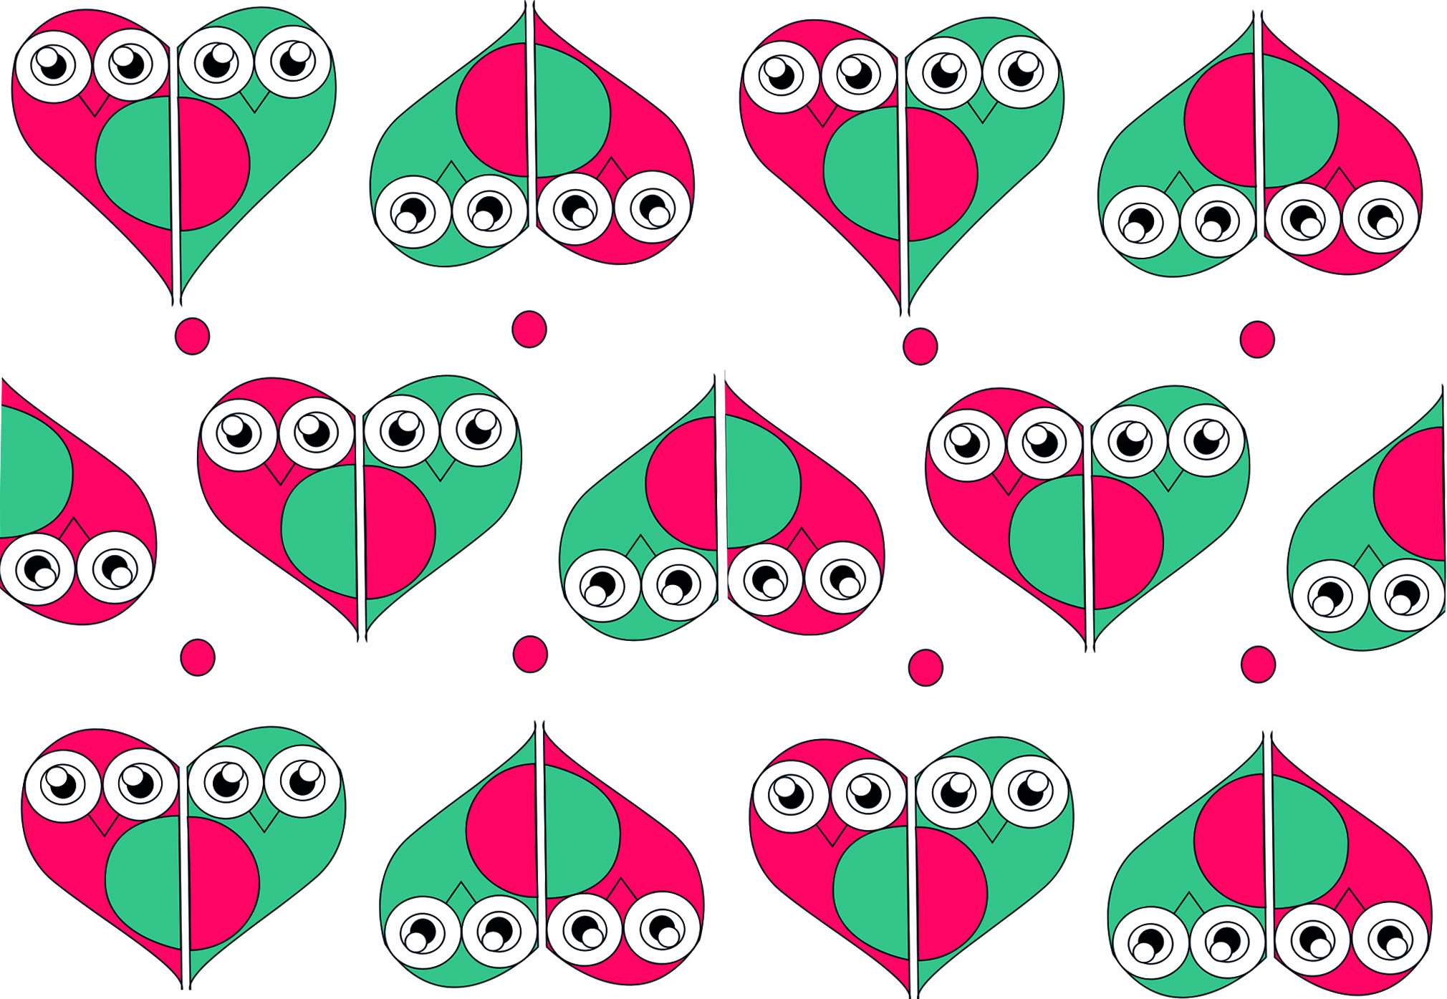
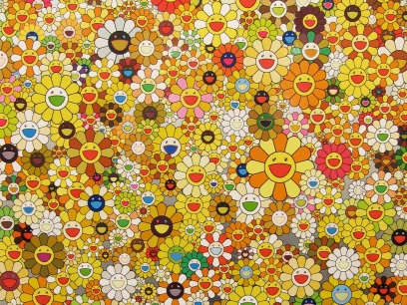

Formal Tasks for Evidence of Learning: Ongoing throughout the term…

Stage 5 Visual Design – Year 10

Learning Context/ Units of Work:

“Sculpture By The Sea”, “The Commercial World”

Types of Tasks:

Formal Tasks for Evidence of Learning: Ongoing throughout the term…

Visual Design ~ Performance Descriptor

Areas for Assessment
Making
Critical and historical interpretations

Grade A

A student at this grade typically:
- makes sophisticated visual design artworks with a perceptive understanding of how the four frames and conceptual framework can be used to develop meaning and represent ideas and interests in the world.
- demonstrates highly developed technical accomplishment and refinement in making and resolving sophisticated visual design artworks in the forms of print, object and/or space-time. They experiment, work with autonomy, and reflect on their actions, judgements and artistic intentions to make informed choices about their visual design artworks.
- synthesises their understanding of practice, the conceptual framework and the frames to confidently interpret, explain and make judgements about visual design.
- demonstrates a perceptive understanding of the function of and relationships between the agencies of the conceptual framework, and how the frames can be used to represent a point of view.

Grade B

A student at this grade typically:
- makes accomplished visual design artworks with a clear understanding of how the four frames and agencies of the conceptual framework can be used to develop meaning and represent ideas and interests in the world.
- demonstrates well-developed technical accomplishment and refinement to make visual design artworks in the forms of print, object and/or space-time. They experiment and reflect on their actions, judgements and artistic intentions to make visual design artworks.
- interprets, explains and makes judgements about visual design, applying an understanding of practice, the conceptual framework and the frames.
- demonstrates a clear understanding of the function of and relationships between the agencies of the conceptual framework, and how the frames can be used to represent a point of view.

Grade C

A student at this grade typically:
- makes a variety of visual design artworks with an understanding of how the frames and agencies of the conceptual framework can be used to develop meaning and represent ideas and interests in the world.
- demonstrates sound technical accomplishment in making visual design artworks in the forms of print, object and/or space-time that represent their actions, judgements and artistic intentions.
- interprets, explains and makes judgements about visual design by engaging with aspects of practice, the conceptual framework and some of the frames.
- demonstrates understanding of the function of and relationships between some agencies of the conceptual framework, and how some frames can be used to represent a point of view.

Grade D

A student at this grade typically:
- makes visual design artworks, and identifies how some of the frames and agencies of the conceptual framework can be used to explore ideas and interests in the world.
- represents their artistic intentions in visual design artworks in the forms of print, object and/or space-time, demonstrating some technical accomplishment.
- makes limited interpretations and judgements about visual design, involving a foundational understanding of practice and the conceptual framework, and some of the frames.
- recognises the function of, and relationships between, some agencies of the conceptual framework, and how some frames can be used to represent a point of view.

Grade E

A student at this grade typically:
- makes simple visual design artworks with an elementary understanding of the frames and the conceptual framework.
- recognises that ideas, interests in the world and artistic intentions can be represented in the forms of print, object and/or space-time, and demonstrates very limited technical accomplishment.
- makes simple interpretations about visual design, with some reference to practice, the frames and conceptual framework.
- with teacher support, recognises some function of and relationships between some agencies of the conceptual framework, and that the frames can be used to represent a point of view.

